IEEE P802.15
Wireless Personal Area Networks

Project | IEEE P802.15 Working Group for Wireless Personal Area Networks (WPANs)
Title | LB213/D02 comment resolution -- Note on MessageContent subfields -- CIDs 284, 328
Date Submitted | May 12, 2025
Sources | Alex Krebs (Apple)  krebs @ apple.com
Re:
Abstract
Purpose | To propose resolution for MMS related comments for “P802.15.4ab™/D02 Draft Standard for Low-Rate Wireless Networks”.
Notice | This document does not represent the agreed views of the IEEE 802.15 Working Group or IEEE 802.15.4ab Task Group. It represents only the views of the participants listed in the “Sources” field above. It is offered as a basis for discussion and is not binding on the contributing individuals. The material in this document is subject to change in form and content after further study. The contributors reserve the right to add, amend or withdraw material contained herein.

Name | Index # | Page | Sub-clause | Line # | Comment | Proposed Change
Rolfe, Benjamin | 284 | 27 | 8.3.4 |  | Notes are informative, and shall not contain reqiurements. In this case "may" is misused, to state a posibility rather than an optional requirement. Sigh. | Change "Note that the CompactMessageContent may contain different subfields that may require different handling" to "Note that the CompactMessageContent might contain different subfields that require different handling
VERSO, BILLY | 328 | 27 | 8.3.4 | 9 | This note does not make sense. The CompactMessageContent is a set of octets which by definition has no structure/subfields etc. The text here should say what the MAC needs to do with CompactMessageContent, it is insufficient specification of the MAC functionality to say it may have content that may need processing. "See 10.39.11 for details." is insufficient to cover what is required here since CompactMessageContent parameter and its handling are not mentioned/specified in that clause, either. | Change the language to specify exactly what the MAC is to do with the set of octets supplied in this primitive's CompactMessageContent parameter. If it simply just sends them then let's say that, otherwise we should be more spefific about what we expect the MAC to with this string of octets. Perhaps a more structured input and description should be added. The SMC TLV field (defined later) suggests that the support of particular messages is someting decided/done above the MAC.

Discussion: D02 says:
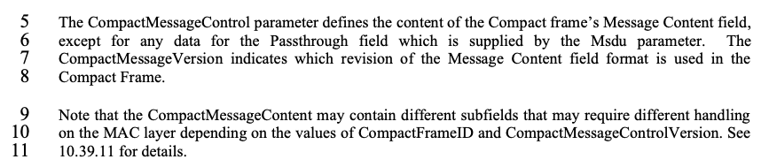
Regarding CID 328, for transmission the tranceiver would simply put the CompactMessageContent as a array of octets and no explicit action aside putting the octets into the MessageContent field is required by the lower layers. Same thing is true for receiving, the lower layers would simply forward the MessageContent field. The meaning of the original text is referring to that the MessageContent might contain subfields, e.g. ReplyTime, which might be filled or used by the lower layers. But that would not state a contradiction. The proposed resolution therefore could simply be to accept CID 284, which makes the note more informative.

Proposed resolution/Disposition detail:
CID 284: Revised.
CID 328: Revised.

Instruction to the editor: Remove lines 9-11 on page 27.

