**IEEE P802.15**

**Wireless Personal Area Networks**

|  |  |
| --- | --- |
| Project | IEEE P802.15 Working Group for Wireless Personal Area Networks (WPANs) |
| Title | **LB213/D02 comment resolution -- various CIDs p.65 to p.71** |
| Date Submitted | June 23, 2025 |
| Sources | Alex Krebs (Apple)  krebs @ apple.com |
| Re: |  |
| Abstract |  |
| Purpose | To propose resolution for MMS related comments for “P802.15.4ab™/D02 Draft Standard for Low-Rate Wireless Networks”. |
| Notice | This document does not represent the agreed views of the IEEE 802.15 Working Group or IEEE 802.15.4ab Task Group. It represents only the views of the participants listed in the “Sources” field above.It is offered as a basis for discussion and is not binding on the contributing individuals. The material in this document is subject to change in form and content after further study. The contributors reserve the right to add, amend or withdraw material contained herein. |

**Table of contents**

CID 388 3

CID 390 4

CID 162 5

CID 164 6

CID 167 7

CID 233 8

CID 417, 418 9

# CID 388

|  |  |  |  |  |  |  |
| --- | --- | --- | --- | --- | --- | --- |
| **Name** | **Index #** | **Page** | **Sub-clause** | **Line #** | **Comment** | **Proposed Change** |
| VERSO, BILLY | 388 | 65 | 10.39.2 | 21 | I think the ranging round may be bigger than these three phases, and indeed we have cases where there are multiple such triplets as sub-rounds in a single ranging round. In this figure showing the three "ranging phases", rather than show this as a ranging round just show the three phases without the upper rectangle. | Remove upper rectangle "ranging round" from Figure 26. |

Discussion: n/a

Proposed resolution: Accepted.

Disposition detail: n/a

# CID 390

|  |  |  |  |  |  |  |
| --- | --- | --- | --- | --- | --- | --- |
| **Name** | **Index #** | **Page** | **Sub-clause** | **Line #** | **Comment** | **Proposed Change** |
| VERSO, BILLY | 390 | 65 | 10.39.2 | 34 | Given that NBA channel 2 is somewhat special being the default for the initialisation, (and the only channel allowed for advertising packets), which I believe to be because it is not occupied by UNII3 Wi-Fi channels, .... should special measures be recommended / taken to keep this channel somewhat free from NBA ranging traffic. | Maybe exclude this channel from default channel switching, map and/or include some statement recommending it be reserved for init phase packets and not used (by default) for control phase? |

Discussion: Yes, but no.

Proposed resolution: Rejected.

Disposition detail: Little impact to initialization channel from general ranging.



# CID 164

|  |  |  |  |  |  |  |
| --- | --- | --- | --- | --- | --- | --- |
| **Name** | **Index #** | **Page** | **Sub-clause** | **Line #** | **Comment** | **Proposed Change** |
| MAMAN, MICKAEL | 164 | 67 | 10.39.3.2 | 28 | The process is the same after receiving Start of Ranging compact frame and not Advertising confirmation compact frame | change "Advertising confirmation" by "Start of Ranging" |

Discussion: Yes, but also it is the responder (not the initiator) that receives the SOR

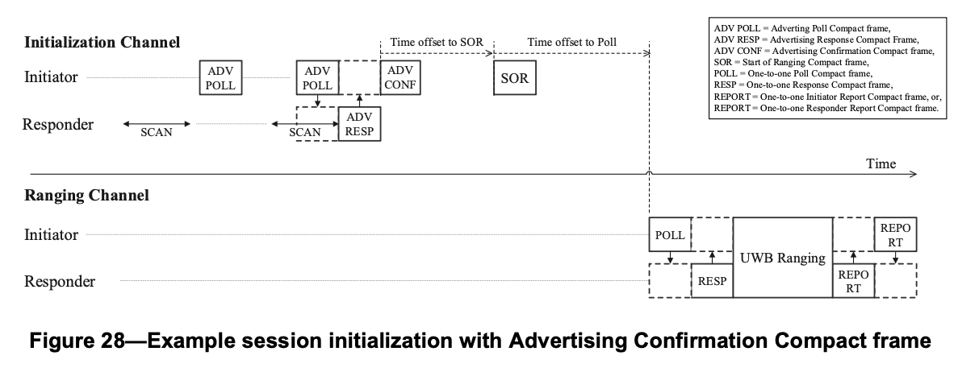

Proposed resolution: Revised.

Disposition detail: Instruction to editor: On p.68 l.28 change sentence to:

The process after a Start of Ranging frame is the same irrespective of whether coordination is active or inactive.



# 

# CID 233

|  |  |  |  |  |  |  |
| --- | --- | --- | --- | --- | --- | --- |
| **Name** | **Index #** | **Page** | **Sub-clause** | **Line #** | **Comment** | **Proposed Change** |
| PAKROOH, POORIA | 233 | 71 | 10.39.3.5 | 15 | Selected NB channels should a subset of the proposed ones by Responder to ensure interoperability. | Change to: "The initiator shall set the value of the NB Channel Map field of the Start of Ranging Compact frame such that the selected channels are a subset of channels selected in the NB channel map field of the Advertising Response compact frame." |

Discussion: Proposed change is more easy to read.

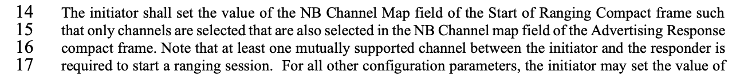

Proposed resolution: Accepted.

Disposition detail: n/a.

# CID 417, 418

|  |  |  |  |  |  |  |
| --- | --- | --- | --- | --- | --- | --- |
| **Name** | **Index #** | **Page** | **Sub-clause** | **Line #** | **Comment** | **Proposed Change** |
| VERSO, BILLY | 417 | 71 | 10.39.3.5 | 31 | This reads like there may only one index, so I think it should be plural "indexes" to indicate that there are many indexes used. Also | Change to "indexes used …" |
| VERSO, BILLY | 418 | 71 | 10.39.3.5 | 31 | This is the first reference to channel switching. I am a little confused about where the channel switch occurs, i.e., when there are multiple ranging rounds per ranging block, where the initiator is having different ranging rounds to range to different responders, if the switch only happens per block does the initiator and all the responders stay on the same NB channel for the whole block? | Rather than try to clarify it here maybe instead delete "during the first and all following ranging blocks" and make sure the protocol is clear in 10.39.8.4. |

Discussion: CID 417: existing text is grammatically incorrect, and for CID 418 the proposed change reduces the chances of a conflict with the one-to-many modes (which may want to implement a different rule for channel switching, as the commenter anticipates).



Proposed resolution: (both) Accepted.

Disposition detail: n/a.