IEEE P802.15
Wireless Personal Area Networks

Project | IEEE P802.15 Working Group for Wireless Personal Area Networks (WPANs)
Title | LB213/D02 comment resolution -- various CIDs -- p.111 to p.201
Date Submitted | July 28, 2025
Sources | Alex Krebs (Apple)  krebs @ apple.com
Re:
Abstract
Purpose | To propose resolution for MMS related comments for “P802.15.4ab™/D02 Draft Standard for Low-Rate Wireless Networks”.
Notice | This document does not represent the agreed views of the IEEE 802.15 Working Group or IEEE 802.15.4ab Task Group. It represents only the views of the participants listed in the “Sources” field above. It is offered as a basis for discussion and is not binding on the contributing individuals. The material in this document is subject to change in form and content after further study. The contributors reserve the right to add, amend or withdraw material contained herein.

Table of contents

CID 536 3
CID 545 4
CID 192 5
CID 547 6
CID 553 6
CID 556 7
CID 272, 273, 274, 275 9
CID 555 10
CID 558 11
CID 32, 33 12
CID 626 13
CID 4 14
CID 7 15

CID 536

Name | Index # | Page | Sub-clause | Line # | Comment | Proposed Change
VERSO, BILLY | 536 | 111 | 10.39.11.3.1 | 14 | This statement is an optimisation of what can be sginalled in SMV TLVs. Question: Should we have similar optimisations/statements for other frame transmissions, in similar terms of expected support. | Consider whether this is a good thing to do and add the appropriate statements as needed, for one to many and other flavours of message or field inclusions.

Discussion: Note that we added below text as per resolution of CID 452, so we can extend on this. Tbd. if we want to reassign completion of this comment regarding "other flavours" to other participants?
Proposed resolution: Revised.
Disposition detail:

Instruction to editor: Change clause 10.39.3.9 as per below:

10.39.3.9 Supported message control list indication
The initiator (controller) may indicate the supported message ID field values for each Compact frame by
referencing the supported Compact Frame ID values and their Message Control and Message Version values
using the SMID TLVs field. Subclause 10.39.11.1.3.2 details the message encodings.

For example, a SMID_TLVs to indicate support for basic one-to-one ranging with extended support for
Presence Bitmap signaling in Poll and Response frames with Message Control equal to 1 is represented by the following SMID_TLVs field:

{ 0x00, 0x01, 0x00, //SMC_Tag=0 (Advertising Poll), SMC Length=1, SMC_Values=0
0x01, 0x01, 0x00, //SMC_Tag=1 (Advertising Response), SMC Length=1, SMC_Values=0
0x02, 0x01, 0x00, //SMC_Tag=2 (Start of Ranging), SMC Length=1, SMC_Values=0
0x03, 0x02, 0x00, 0x10, //SMC_Tag=3 (One-to-one Poll), SMC Length=2, SMC_Values={0x00, 0x10}
0x04, 0x02, 0x00, 0x10, //SMC_Tag=4 (One-to-one Response), SMC Length=2, SMC_Values={0x00, 0x10}
0x05, 0x01, 0x00, //SMC_Tag=5 (One-to-one Initiator Report), SMC Length=1, SMC_Values=0
0x06, 0x01, 0x00 } //SMC_Tag=6 (One-to-one Responder Report), SMC Length=1, SMC_Values=0

An alternative, more concise representation using the Message Control 0 set defined in 10.39.11.3.1 is:

{ 0x00, 0x01, 0x00, //SMC_Tag=0 (Advertising Poll), SMC Length=1, SMC_Values=0
0x03, 0x01, 0x10, //SMC_Tag=3 (One-to-one Poll), SMC Length=2, SMC_Values={0x00, 0x10}
0x04, 0x01, 0x10 } //SMC_Tag=4 (One-to-one Response), SMC Length=2, SMC_Values={0x00, 0x10}

The responder (controlee) may request ranging session configuration in the Advertising Response Compact
frame and may indicate the supported message ID list for each Compact frame by referencing the
supported Compact Frame ID field values and their Message ID field values using the SMID TLVs field.
After the supported message control lists have been exchanged, devices shall use values for Compact Frame
ID and Message ID indicated in the peer's SMID TLVs field when transmitting Compact frames to the
peer.

CID 545

Name | Index # | Page | Sub-clause | Line # | Comment | Proposed Change
VERSO, BILLY | 545 | 114 | 10.39.11.3.3 | 13 | I think we could say here that this as an RPA HASH, rather than above on line 2. (And do the same on line 25 too). | On lines 13 and 24, change the phrase "identifies the address of a responder" to "is an RPA Hash field value generated using the RPA Prand field value from the initiator's Advertising Poll Compact frame and the IRK of the responder". And remove the sentence from line 2.

Discussion: Accepted to be confirmed with Youngwan et al.
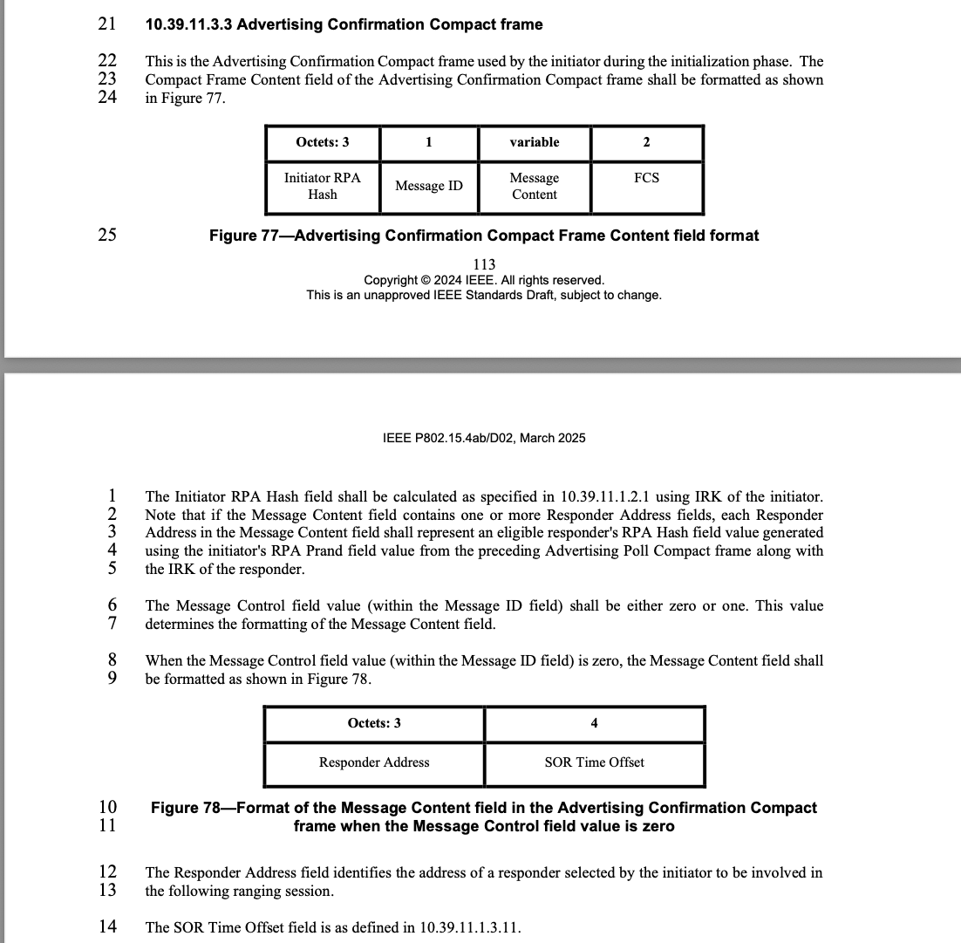
Proposed resolution: Accepted.
Disposition detail: n/a.

CID 192

Name | Index # | Page | Sub-clause | Line # | Comment | Proposed Change
MAMAN, MICKAEL | 192 | 115 | 10.39.11.3.4 | 10 | missing value "one" for Message Control field of start of ranging compact frame | add "one"

Discussion: Yes, "one" is apparently missing in this line.
Proposed resolution: Accepted.
Disposition detail: n/a

CID 547

Name | Index # | Page | Sub-clause | Line # | Comment | Proposed Change
VERSO, BILLY | 547 | 115 | 10.39.11.3.3 | 7 | In the MCPS-DATA.request, the NHL provides the IRK of the receiving device via the DstAddr and/or the IRK of the transmitting device in the SourceIrk paramete, so it is the NHL that is making this choice depending on which it provides? The wording here does not reflect how the primitive is used | Reword to say something like: RPA Hash field shall be calculated as specified using the IRK supplied in the MCPS-DATA.request. For a single responder the DstAddr parameter provides responders IRK, otherwise the initiator's IRK provided by the SourceIrk parameter is used.

Discussion: That's a good suggestion to make the behaviour more comprehensive.
Proposed resolution: Revised.
Disposition detail: Instruction to editor: Change clause as follows:

When the Start of Ranging Compact frame is transmitted to a single responder selected during contention-
based initialization and setup (as described in 10.39.3.6), the RPA Hash field shall be calculated as specified
in 10.39.11.1.2.1 using the responder's IRK supplied in the MCPS-DATA.request provided the DstAddr parameter. Otherwise, the RPA Hash field shall be calculated as specified
in 10.39.11.1.2.1 using the IRK of the initiator provided by the SourceIrk parameter.

CID 553

Name | Index # | Page | Sub-clause | Line # | Comment | Proposed Change
VERSO, BILLY | 553 | 118 | 10.39.11.3.5 | 15 | In the MCPS-DATA.request, the NHL provides the IRK of the receiving device via the DstAddr and/or the IRK of the transmitting device in the SourceIrk paramete, so it is the NHL that is making this choice depending on which it provides? The wording here does not reflect this. | Reword to say something like: RPA Hash field shall be calculated as specified using the IRK supplied in the MCPS-DATA.request. For a single responder the DstAddr parameter provides responders IRK, otherwise the initiator's IRK provided by the SourceIrk parameter is used. And... Similarly review/revise similar statements on RPA Hash and IRKs for all compact frame descriptions where similar statements are made.

Discussion: Good idea to make it more comprehensive.
Proposed resolution: Revised.
Disposition detail:

When the One-to-one Poll Compact frame is transmitted to a single responder selected during contention-
based initialization and setup (as described in 10.39.3.6), the RPA Hash field shall be calculated as specified
in 10.39.11.1.2.1 using the responder's IRK supplied in the MCPS-DATA.request provided in the DstAddr parameter. Otherwise, the RPA Hash field shall be calculated as specified
in 10.39.11.1.2.1 using the IRK of the initiator provided by the SourceIrk parameter.

CID 556

Name | Index # | Page | Sub-clause | Line # | Comment | Proposed Change
VERSO, BILLY | 556 | 120 | 10.39.11.3.6 | 26 | I guess this means in the MCPS-DATA.request, DstAddr mode is NONE and the SrcAddMode is COMPACT so tyhat the device sused the SourceIrk parameter | Say something about this IRK being supplied by the SourceIrk parameter in the MCPS-DATA.request.  Similarly review/revise similar statements on RPA Hash and IRK for all compact frame descriptions where similar statements are made.

Discussion: Good idea.
Proposed resolution: Revised.
Disposition detail: Instruction to editor: Change clause on p.120 l.26 as follows:

The Responder RPA Hash field shall be calculated as specified in 10.39.11.1.2.1 using the IRK of the
responder supplied in the MCPS-DATA.request provided by the SourceIrk parameter.

Instruction to editor: Change clause on p.122 l.5 as follows:

The Initiator RPA Hash field shall be calculated as specified in 10.39.11.1.2.1 using the initiator's IRK
supplied in the MCPS-DATA.request provided by the SourceIrk parameter.

Instruction to editor: Change clause on p.123 l.6 as follows:

The Responder RPA Hash field shall be calculated as specified in 10.39.11.1.2.1 using the responder's IRK supplied in the MCPS-DATA.request provided by the SourceIrk parameter.

Instruction to editor: Change clause on p.124 l.30 as follows:

The Initiator RPA Hash shall be calculated as specified in 10.39.11.1.2.1 using the initiator's IRK supplied in the MCPS-DATA.request provided by the SourceIrk parameter.

Instruction to editor: Change clause on p.131 l.1 as follows:

The Responder RPA Hash field shall be calculated as specified in 10.39.11.1.2.1 using the responder's IRK supplied in the MCPS-DATA.request provided by the SourceIrk parameter.

Instruction to editor: Change clause on p.132 l.10 as follows:

The Responder RPA Hash field shall be calculated as specified in 10.39.11.1.2.1 using the responder's IRK supplied in the MCPS-DATA.request provided by the SourceIrk parameter.

Instruction to editor: Change clause on p.133 l.27 as follows:

The Responder RPA Hash field shall be calculated as specified in 10.39.11.1.2.1 using the responder's IRK supplied in the MCPS-DATA.request provided by the DstAddr parameter.

CID 272, 273, 274, 275

Name | Index # | Page | Sub-clause | Line # | Comment | Proposed Change
QIAN, BIN | 272 | 118 | 10.39.11.3.5 | 26 | The reason for having all-zero Message Content may not be clear to readers not involved in the standard development | Change the sentence to "When the Message Control field value is zero the Message Content field shall consist of two octets with the value of zero as shown in Figure 87 to assist CFO estimation"
QIAN, BIN | 273 | 120 | 10.39.11.3.6 | 30 | The reason for having all-zero Message Content may not be clear to readers not involved in the standard development | Change the sentence to "When the Message Control field value is zero the Message Content field shall consist of five octets with the value of zero as shown in Figure 91 to assist CFO estimation"
QIAN, BIN | 274 | 125 | 10.39.11.3.9 | 8 | The reason for having all-zero Message Content may not be clear to readers not involved in the standard development | Change the sentence to "When the Message Control field value (within the Message ID field) is zero the Message Content field shall be formatted as shown in Figure 101 to assist CFO estimation"
QIAN, BIN | 275 | 130 | 10.39.11.3.10 | 4 | The reason for having all-zero Message Content may not be clear to readers not involved in the standard development | Change the sentence to "When the Message Control field value is zero, the Message Content field shall be formatted as shown in Figure 113 to assist CFO estimation"

Discussion: Adding "to assist CFO estimation" makes it more comprehensible.
Proposed resolution: Accepted.
Disposition detail: n/a

CID 555

Name | Index # | Page | Sub-clause | Line # | Comment | Proposed Change
VERSO, BILLY | 555 | 120 | 10.39.11.3.5 | 17 | "Either the NB Channel Map field or the NB Channel field may be present, but not both. "... Given that they are mutually exclusive. We can save having the NB Channel Present bit in the presence bitmap and reuse the NB Channel Map Present field to also signal presence of the NB Channel field. (I have already identified a need for another presence bit, see my comment on p121-L12 | Rationalise to a single bit, to indicate that channel specification info is present in the message. Which type then being determined by the value of the Long-Term Parameters Update field.

Discussion: Pooria and Rojan are more knowledgeable about this eventually.
Proposed resolution: Reassign to tbd.
Disposition detail: n/a

CID 558

Name | Index # | Page | Sub-clause | Line # | Comment | Proposed Change
VERSO, BILLY | 558 | 121 | 10.39.11.3.6 | 5 | The format Figure 92,can could cover all the cases with a single format definition, i.e., set the presence octet to all 0 and allow 4 padding octets, and give exactly same content as Figure 91. Even if there is good reason for having as sepcial frame for the figure 91 case. We could still allow the more general encodeing to also have that same ability by deleting the paragraph on line 20, and allowing for up to 4 padding bytes. | Consider reducing to a single format, or, allowing for the Figure 91 format to also reduce to a five 0x00 octets when the other fields are not needed.

Discussion: Message Control 0 was introduced to form a basic O2O ranging set of messages, without the need for more elaborate MAC data/length/bitmap processing. Let's keep it as such.
Proposed resolution: Rejected.
Disposition detail: Simplicity preferred.

CID 32, 33

Name | Index # | Page | Sub-clause | Line # | Comment | Proposed Change
CHITRAKAR, ROJAN | 32 | 122 | 10.39.11.3.7 | 12 | What happens if the Initiator encounters some error during timing measurements? How does it indicate the error condition? The comment is also applicable for other variants of the Report frame. | Use an impossible value (e.g., 0) of the Round-trip Time to indicate an error in the measurement.
CHITRAKAR, ROJAN | 33 | 122 | 10.39.11.3.7 | 24 | What happens if the Initiator encounters some error during timing measurements? How does it indicate the error condition? The comment is also applicable for other variants of the Report frame. | Use an impossible value (e.g., 0) of the Reply Time to indicate an error in the measurement.

Discussion: We can reserve the upper 16 integer values for error codes. Let's make this a generic solution instead of changing all messages seperately. Tbd.: more errors than shown below.
Proposed resolution: Revised.
Disposition detail: Instruction to editor: Add clause "Ranging error codes" somewhere, e.g., under 10.39.11.3.18 "General" as follows:

10.39.11.3.18.X Ranging Error Codes

The following values are reserved for signaling ranging errors via the Reply Time and Round-trip time fields in described in 10.39.11.3:

Value | Description
0xffffffffff | Generic ranging error.
0xfffffffff0- 0xfffffffffe | reserved
Table XX -- Ranging Error Codes

CID 626

Name | Index # | Page | Sub-clause | Line # | Comment | Proposed Change
VERSO, BILLY | 626 | 201 | 11.1.3.15 | 14 | Just wondering about the pre-existing O-QPSK PHY channel numbering in the base standard. I assume there is also a channel 1, 2, 3 there also. Since we are amending it, we should be clear that any O-QPSK PHY channel we mention is not confused with the original O-QSPK channels, and if so add some qualifier. | Review the rest of the 4ab text (and base standard text?) and decide if this is an issue or not, and if it is make sure to add band modifiers 5800 MHz and 6200 MHz (and the bands of the base standard in the base standard?) as appropriate to make it unambiguous..

Discussion: In the base standard, channel numbering starts per band at k=0, always. Section 10.39.8.2 Channel bands in this amendment says " the 250 channels defined in 11.1.3.15". Therefore I think it's sufficiently defined.
Proposed resolution: Rejected.
Disposition detail: n/a

CID 4

Name | Index # | Page | Sub-clause | Line # | Comment | Proposed Change
Aldana, Carlos | 4 | 145 | 10.39.12 | 1 | macmmsnbinitchannel should be consistent with CAD document 15-23-452-11 that states "Periodic NB packet transmissions on fixed channels such as background advertising and control traffic are allocated in 4ab in newly allocated spectrum outside of the channel map used by 802.11 WLAN such that no interference is cast " | Change the range from "0 to 249" to a range that is consistent with the statement

Discussion: Makes sense to change the default value for generic traffic to exclude the lower band edge channels for advertising packets.
Proposed resolution: Revised
Disposition detail: Instruction to editor: Change Default range to: "Channels 4 to 249".

CID 7

Name | Index # | Page | Sub-clause | Line # | Comment | Proposed Change
Aldana, Carlos | 7 | 201 | 11.1.1 | 10 | I've heard the response "more channels is better" when discussing NB channel maps. The spectrum from 5850-5875 is available in Europe. | Change Table 11-1 and equations in lines 17 and 18 to reflect this.

Discussion: UNII-4 is not available for narrowband, or has indoor restrictions in most regulatory domains globally, including the US and Canada.
Proposed resolution: Rejected.
Disposition detail: Regulatory constraints.

