IEEE P802.22
Wireless RANs
Proposed Text of PHY technical items related to Section 9.1 and 9.2 of the Std.802.22-2011
Date: 2013-04-04
Author(s):
Name | Company | Address | Phone | email
Masayuki Oodo | NICT | 3-4, Hikarino-oka, Yokosuka, 239-0847, Japan |  | moodo@nict.go.jp
Zhang Xin | NICT | 20 Science Park Road, #01-09A/10 TeleTech Park, Singapore |  | amy.xinzhang@ieee.org
Chunyi Song | NICT | 3-4, Hikarino-oka, Yokosuka, 239-0847, Japan |  | songe@ieee.org
Keiichi Mizutani | NICT | 3-4, Hikarino-oka, Yokosuka, 239-0847, Japan |  | songe@ieee.org
Chang-Woo Pyo | NICT | 3-4, Hikarino-oka, Yokosuka, 239-0847, Japan |  | cwpyo@nict.go.jp
Pin-Hsun Lin | NICT | 3-4, Hikarino-oka, Yokosuka, 239-0847, Japan |  | pslin@nict.go.jp
Gabriel Porto Vilardi | NICT | 3-4, Hikarino-oka, Yokosuka, 239-0847, Japan |  | gpvillardi@nict.go.jp
Hiroshi Harada | NICT | 3-4, Hikarino-oka, Yokosuka, 239-0847, Japan |  | harada@ieee.org
Abstract
This document contains the proposed text of PHY technical items related to Section 9.1 and 9.2 of the current 802.22 standard.
Notice: This document has been prepared to assist IEEE 802.22. It is offered as a basis for discussion and is not binding on the contributing individual(s) or organization(s). The material in this document is subject to change in form and content after further study. The contributor(s) reserve(s) the right to add, amend or withdraw material contained herein.

Release: The contributor grants a free, irrevocable license to the IEEE to incorporate material contained in this contribution, and any modifications thereof, in the creation of an IEEE Standards publication; to copyright in the IEEE’s name any IEEE Standards publication even though it may include portions of this contribution; and at the IEEE’s sole discretion to permit others to reproduce in whole or in part the resulting IEEE Standards publication. The contributor also acknowledges and accepts that this contribution may be made public by IEEE 802.22.

Patent Policy and Procedures: The contributor is familiar with the IEEE 802 Patent Policy and Procedures
<http://standards.ieee.org/guides/bylaws/sb-bylaws.pdf>, including the statement "IEEE standards may include the known use of patent(s), including patent applications, provided the IEEE receives assurance from the patent holder or applicant with respect to patents essential for compliance with both mandatory and optional portions of the standard." Early disclosure to the Working Group of patent information that might be relevant to the standard is essential to reduce the possibility for delays in the development process and increase the likelihood that the draft publication will be approved for publication. Please notify the Chair Apurva N. Mody <apurva.mody@ieee.org> as early as possible, in written or electronic form, if patented technology (or technology under patent application) might be incorporated into a draft standard being developed within the IEEE 802.22 Working Group. If you have questions, contact the IEEE Patent Committee Administrator at <patcom@ieee.org>.
9. PHY

9. X Proposed PHY

This clause specifies the basic technologies for the standardization of the physical (PHY) layer for WRAN systems. The specification is for a system that uses vacant channels to provide wireless communication over a distance of up to 100 km, the propagation time over the first 30 km range being absorbed by the TTG at the PHY layer and the propagation time beyond 30 km being absorbed by proper MAC packet scheduling at the BS, as well as time buffers before and after the opportunistic bursts (ranging, BW request, and UCS notification) and before and after the CBP burst.

The system reference frequency is the center frequency of the channel in which the transmitter and the receiver equipment operates. Annex A lists the frequencies corresponding to the channels used for WRAN operation in various regulatory domains.

The PHY specification is based on an orthogonal frequency division multiple access (OFDMA) scheme where information to (downstream) or from (upstream) multiple CPEs are modulated on orthogonal subcarriers using Inverse Fourier Transforms. The main system parameters are provided in Table 198.

Table 198 — System parameters for WRAN
Parameters | Specifications | Remark
Frequency Range | 54~862 MHz
Channel bandwidth | 6, 7, or 8 MHz | According to regulatory domain (see Annex A).
Data rate | 3.61 to 18.07 Mbit/s for SISO case  14.44 to 72.28 Mbit/s for 4 × 4 MIMO case | See Table 202
Spectral Efficiency | 0.60 to 3.01 bit/(s・Hz) | See Table 202
Payload modulation | QPSK, 16-QAM, 64-QAM | BPSK used for preambles, pilots and CDMA codes.
Transmit EIRP | 4W maximum for CPEs. 4W maximum for BS’s in the USA regulatory domain. | Maximum EIRP for BS’s may vary in other regulatory domains.
Multiple Access | OFDMA
FFT Size (N_{FFT}) | 1024
Cyclic Prefix Modes | 1/4, 1/8, 1/16, 1/32
Duplex | TDD

The following subclauses provide details on the various aspects of the PHY specifications.

9.X.1 Symbol description
9.X.1.1 OFDM symbol mathematical representation

(No change)

9.X.1.1.1 Time domain description

The time-domain signal is generated by taking the inverse Fourier transform of the length NFFT vector. The vector is formed by taking the constellation mapper output and inserting pilot and guard tones. At the receiver, the time domain signal is transformed to the frequency domain representation by using a Fourier transform.

Let T_{FFT} represent the time duration of the IFFT output signal. The OFDM symbol is formed by inserting a cyclic prefix of time duration T_{CP} (shown in Figure 128), resulting in a symbol duration of T_{SYM} = T_{FFT} +T_{CP}.

Figure 128 — OFDM symbol format
The specific values for T_{FFT}, T_{CP} and T_{SYM} are given in 9.1.2. The BS determines these parameters and conveys the T_{CP} to T_{FFT} ratio to the CPEs using the FCH (Table 1).

The time at which the FFT window starts within the symbol period for reception at the CPE is determined by the local synchronization strategy to minimize inter-symbol interference due to pre- and post-echoes and any synchronization error, and is implementation dependent.

9.X.1.1.2 Frequency domain description

In the frequency domain, an OFDM symbol is defined in terms of its subcarriers. The subcarriers are classified as: 1) data subcarriers, 2) pilot subcarriers, 3) guard and Null (including DC) subcarriers. The classification is based on the functionality of the subcarriers. The DS and US may have different allocations of subcarriers. The total number of subcarriers is determined by the FFT/IFFT size. The pilot subcarriers are distributed across the bandwidth. The exact location of the pilot and data subcarriers and the symbol’s subchannel allocation is determined by the particular configuration used. All the remaining guard/null subcarriers carry no energy and are located at the center frequency of the channel (DC subcarrier) and at both edges of the channel (guard subcarriers).

9.X.1.2 Symbol parameters
9.X.1.2.1 Subcarrier spacing

The BS and CPEs shall use the 1024FFT mode with the subcarriers spacing specified in Table 199. The subcarrier spacing, ΔF, is dependent on the bandwidth of the channel (6 MHz, 7 MHz, or 8 MHz). Table 199 shows the subcarrier spacing and the corresponding FFT/IFFT period (T_{FFT}) values for the different channel bandwidth options.

Table 199 — Subcarrier spacing and FFT/IFFT period values for different bandwidth options

 | 6 MHz based channels | 7 MHz based channels | 8 MHz based channels
Basic sampling frequency, F_{s} (MHz) | 5.6 | 6.53 | 7.46
Inter-carrier spacing  Δf (Hz)= F_{s} /1024 | 5468.75 | 6380.208… | 7291.6…
FFT/IFFT period,  T_{FFT}(μs)=1/ Δf | 182.857… | 156.734… | 137.142…
Time Unit (ns)  TU=T_{FFT}/1024 | 178.571… | 153.061… | 133.928…

9.X.1.2.2 Symbol duration for different cyclic prefix modes
The cyclic prefix duration T_{CP} could be one of the following derived values: T_{FFT}/32, T_{FFT}/16, T_{FFT}/8, and T_{FFT}/4. The OFDM symbol duration for different values of cyclic prefix is given in Table 200.

Table 200 — Symbol duration for different cyclic prefixes and bandwidth options

 |  | CP=T_{FFT}/32 | CP=T_{FFT}/16 | CP=T_{FFT}/8 | CP=T_{FFT}/4
T_{SYM}  =T_{FFT}+T_{CP}  (μs) | 6 MHz | 188.571… | 194.285… | 205.714… | 228.571…
T_{SYM}  =T_{FFT}+T_{CP}  (μs) | 7 MHz | 161.632… | 166.530… | 176.326… | 195.918…
T_{SYM}  =T_{FFT}+T_{CP}  (μs) | 8 MHz | 141.428… | 145.714… | 154.285… | 171.428..

9.X.1.2.3 Transmission parameters

Table 201 shows the different parameters and their values for the three bandwidths.

Table 201 — OFDM parameters for the three channel bandwidths

TV channel bandwidth (MHz) | 6 | 7 | 8
Total number of subcarriers, N_{FFT} | 1024
Number of guard subcarriers, N_{G}  (L, DC, R) | 192 (96,1,95) for DS  184 (92,1,91) for US
Number of used subcarriers  N_{T}= N_{D}+ N_{P} | 832 for DS  840 for US
Number of data subcarriers, N_{D} | 832 or 416 for DS  840 or 420 for US
Number of pilot subcarriers, N_{P} | 0 or 416 for DS  0 or 420 for US

9.X.1.3 OFDMA basic terms definition
9.X.1.3.1 Tile, slot and data region

In DS, a tile consists of 4 successive active subcarriers and 4 OFDM symbols as shown in Figure 9.X.1.3-1. In US, a tile consists of 4 successive active subcarriers and 7 OFDM symbols as shown in Figure 9.X.1.3-2.

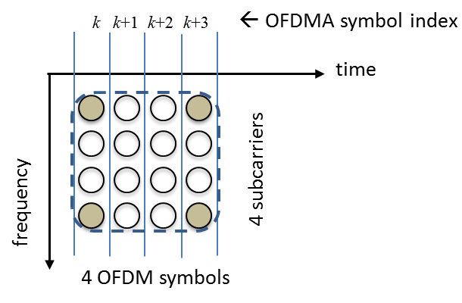
Figure 9.X.1.3.1-1 — Tile configuration for DS

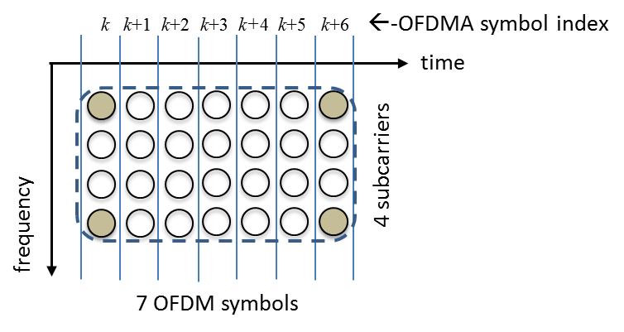
Figure 9.X.1.3.1-2— Tile configuration for US

A slot is the minimum possible data allocation unit. A slot requires both a time and subchannel dimension. In DS, a slot consists of 16 subcarriers and 4 OFDM symbols (or 4 DS tiles) as shown in Figure 9.X.1.3.1-3. In US, a tile consists of 8 subcarriers and 7 OFDM symbols (or 2 US tiles).

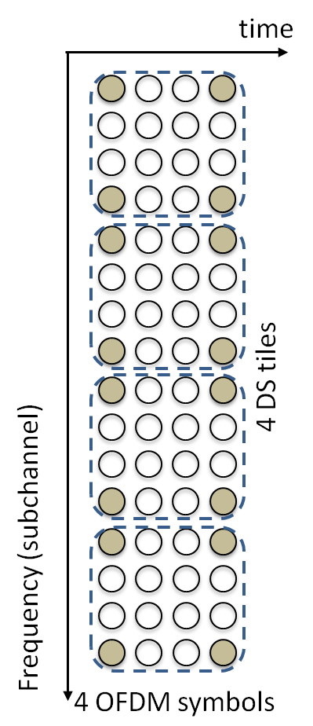
Figure 9.X.1.3.1-3 — Slot configuration for DS

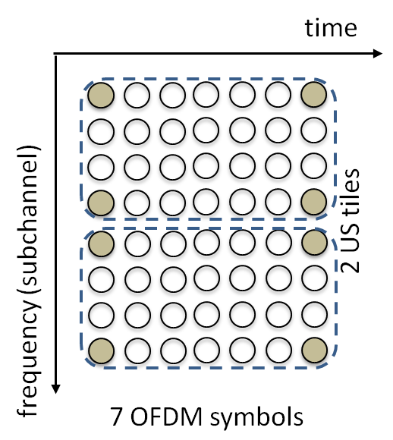
Figure 9.X.1.3.1-4 — Slot configuration for US

A data region is a two-dimensional allocation of a group of contiguous subchannels, in a group of contiguous OFDMA symbols. All the allocations refer to logical subchannels. A two-dimensional allocation may be visualized as a rectangle, such as the 5 × 6 rectangle shown in Figure 9.X.1.3.1-5.

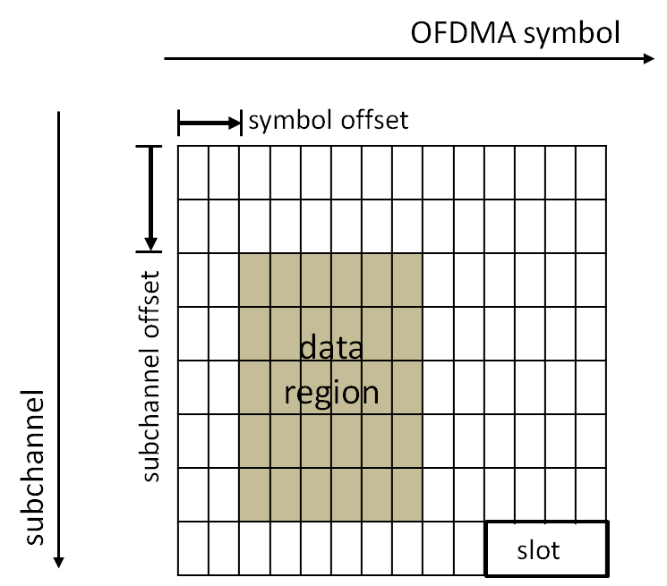
Figure 9.X.1.3.1-5 — Example of a data region that defines an OFDMA allocation

9.X.1.3.2 Data mapping
MAC data shall be processed as described in 9.6 and shall be mapped to a data region (see 9.1.3.1) for DS and US using the algorithms defined below.

DS:
- Segment the data into blocks sized to fit into one slot.
- Each slot shall span one subchannels in the subchannel axis and 4 OFDM symbols in the time axis, as per the slot definition in 9.1.3.1. Map the slots so that the lowest numbered slot occupies the lowest numbered subchannel in the lowest numbered symbol.
- Continue the mapping so that the subchannel index is increased. When the edge of the data region is reached, continue the mapping from the lowest numbered subchannel in the next available symbol.

Figure 9.X.1.3.2-1 illustrates the order in which OFDMA slots are mapped to subchannels and OFDMA symbols in DS.
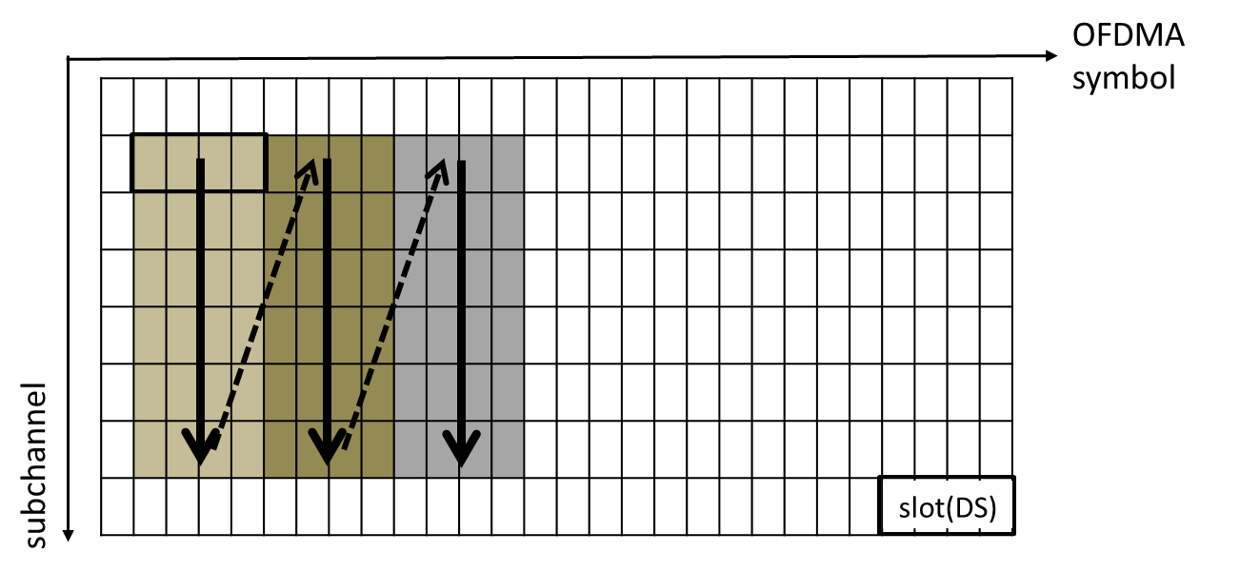

Figure 9.X.1.3.2-1 — Procedure of slot allocation to the burst (data region) in DS

US:

The US mapping consists of two steps. In the first step, the slots allocated to each burst (a data region) are selected. In the second step, the allocated slots are mapped.

Step 1—Allocate slots to bursts.

- Segment the data into blocks sized to fit into one slot.
- Each slot shall span one subchannel in the subchannel axis and 7 OFDM symbols in the time axis, as per the slot definition in 9.X.1.3.1. Allocate the slots so that the lowest numbered slot occupies the lowest numbered symbol in the lowest numbered subchannel.
- Continue allocating such that the OFDMA symbol index is increased. When the edge of the allocated data region is reached, continue allocating from the lowest numbered symbol in the next available subchannel.
- An US allocation is created by selecting an integer number of contiguous slots, according to the ordering of items d) through f). This results in the general burst structure shown by the gray area in Figure 9.X.1.3.2-2.

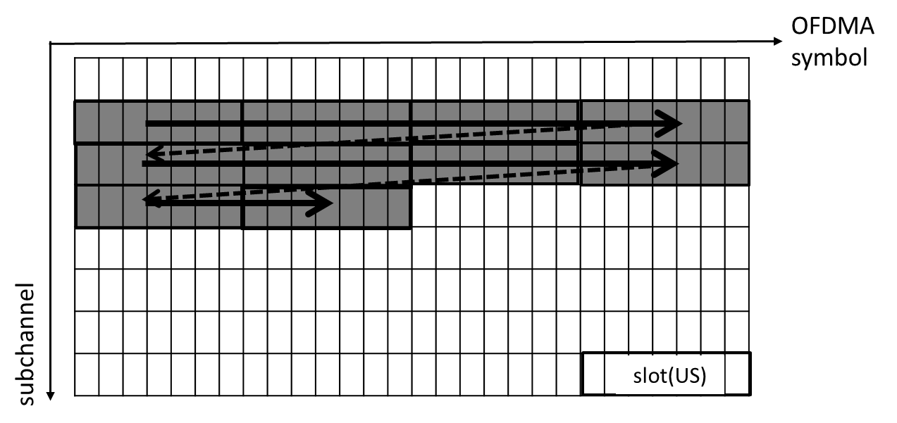
Figure 9.X.1.3.2-2 —Slot allocation to the allocated data region (burst) in US

Step 2—Map slots within the UL allocation.

- Map the slots so that the lowest numbered slot occupies the lowest numbered subchannel in the lowest numbered OFDMA symbol.
- Continue the mapping so that the subchannel index is increased. When the last subchannel is reached, continue the mapping from the lowest numbered subchannel in the next OFDMA symbol that belongs to the UL allocation. The resulting order is shown by the arrows in Figure 9.1.3.2-3.

Figure 9.X.1.3.2-3 illustrates the order in which OFDMA slots are mapped to subchannels and OFDMA symbols in US.
The subchannels referred to in this subclause are logical subchannels,

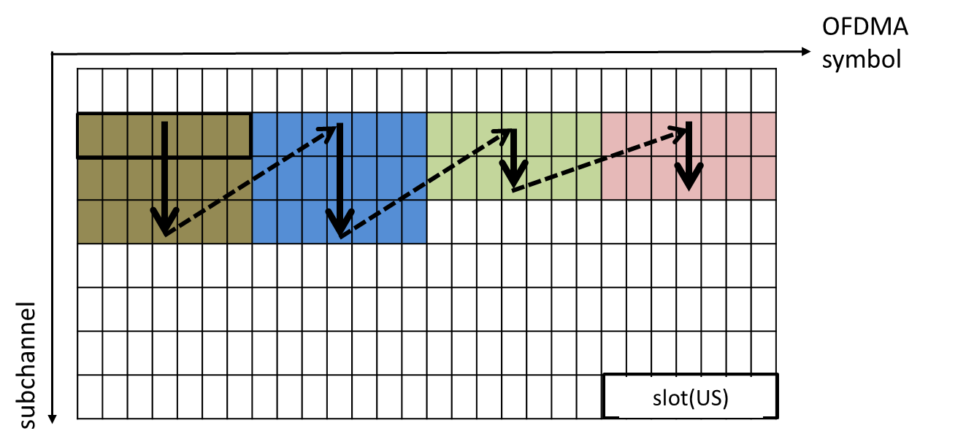
Figure 9.X.1.3.2-3 — Example of mapping slots to subchannels and symbols in the US

9.X.2 Data rates

Table 202 defines the different PHY modulation and encoding modes with their associated parameters along with an example of the resulting gross data rates in the case of the 6 MHz channel bandwidth.

Table 202 — PHY Modes and their related modulations, coding rates
and data rates for T_{CP} = T_{FFT}/16

PHY  Mode | Modulation | Coding rate | Data rate (Mb/s) | Spectral Efficiency⁴  (for 6 MHz bandwidth)
1¹ | BPSK | Uncoded | ⁵ | ⁵
3² | QPSK | 1/2Repetition: 3 | ⁵ | ⁵
4³ | QPSK | 1/2Repetition: 2 | ⁵ | ⁵
5 | QPSK | 1/2 | 3.61 | 0.60
6 | QPSK | 2/3 | 4.82 | 0.80
7 | QPSK | 3/4 | 5.42 | 0.90
8 | QPSK | 5/6 | 6.02 | 1.00
9 | 16-QAM | 1/2 | 7.23 | 1.21
10 | 16-QAM | 2/3 | 9.64 | 1.61
11 | 16-QAM | 3/4 | 10.84 | 1.81
12 | 16-QAM | 5/6 | 12.05 | 2.01
13 | 64-QAM | 1/2 | 10.84 | 1.81
14 | 64-QAM | 2/3 | 14.46 | 2.41
15 | 64-QAM | 3/4 | 16.26 | 2.71
16 | 64-QAM | 5/6 | 18.07 | 3.01

NOTE 1: Mode 1 is only used for CDMA opportunistic bursts.

NOTE 2: Mode 3 is only used for CBP transmission.
NOTE 3: Mode 4 is only used for FCH transmission.
NOTE 4: Spectral efficiency informative values are calculated assuming continuous stream for the given modulation
and FEC modes (i.e., assuming no TTG, RTG or frame headers).
NOTE 5: These modes are for control signal transmissions and there is no need to specify data rate or spectral
efficiency.

