IEEE P802.22
Wireless RANs
Suggested Text Changes for 22b Segmentation
Date: 2014-11-17
Author(s):
Name | Company | Address | Phone | email
Sung-Hyun Hwang | ETRI | Korea | +82-42-860-1133 | shwang@etri.re.kr
Seung-Keun Park | ETRI | Korea | +82-42-860-5993 | seungkp@etri.re.kr
Gwang-Zeen Ko | ETRI | Korea | +82-42-860-4862 | gogogo@etri.re.kr
Myung-Sun Song | ETRI | Korea | +82-42-860-5046 | mssong@etri.re.kr
Hyung-Do Choi | ETRI | Korea | +82-42-860-5814 | choihd@etri.re.kr
Ranga Reddy | Self | US |  | ranga.reddy@me.com
Abstract
This is the suggested text changes for 802.22b segmentation scheme. It is the resolution for 1st WG Letter Ballot CID #218 and 2nd WG Letter Ballot CID #45.
Notice: This document has been prepared to assist IEEE 802.22. It is offered as a basis for discussion and is not binding on the contributing individual(s) or organization(s). The material in this document is subject to change in form and content after further study. The contributor(s) reserve(s) the right to add, amend or withdraw material contained herein.

Release: The contributor grants a free, irrevocable license to the IEEE to incorporate material contained in this contribution, and any modifications thereof, in the creation of an IEEE Standards publication; to copyright in the IEEE’s name any IEEE Standards publication even though it may include portions of this contribution; and at the IEEE’s sole discretion to permit others to reproduce in whole or in part the resulting IEEE Standards publication. The contributor also acknowledges and accepts that this contribution may be made public by IEEE 802.22.

Patent Policy and Procedures: The contributor is familiar with the IEEE 802 Patent Policy and Procedures
<http://standards.ieee.org/guides/bylaws/sb-bylaws.pdf>, including the statement "IEEE standards may include the known use of patent(s), including patent applications, provided the IEEE receives assurance from the patent holder or applicant with respect to patents essential for compliance with both mandatory and optional portions of the standard." Early disclosure to the Working Group of patent information that might be relevant to the standard is essential to reduce the possibility for delays in the development process and increase the likelihood that the draft publication will be approved for publication. Please notify the Chair <Apurva N. Mody> as early as possible, in written or electronic form, if patented technology (or technology under patent application) might be incorporated into a draft standard being developed within the IEEE 802.22 Working Group. If you have questions, contact the IEEE Patent Committee Administrator at <patcom@ieee.org>.

1. Related Comment

This is the resolution for 1st WG Letter Ballot CID # 218 and 2nd WG Letter Ballot CID #45 as described in the following table.

2. Proposed Resolution

In the September 2014 F2F meeting, we have reached on the consensus regarding segmentation scheme. The key features are summaried in the document 22-14/0100r2.

3. Proposed Text Changes

Change the section 7.4b.2 as follows:

7.4b.2 General frame structure for a distributed scheduling mode

Each of the downstream and upstream subframes for a distributed scheduling mode may include two zones: access zone (AZ) and distributed relay zone (DRZ) as shown in Figure E1. Each AZ in the downstream and upstream subframes is used for transmission between an A-BS and CPEs (distributed scheduling A-CPEs or S-CPEs), while each DRZ in the downstream and upstream subframe is used for transmission between a distributed scheduling A-CPE and S-CPEs.

The both of AZs and DRZs in the downstream and upstream subframes are scheduled by an A-BS. For a distributed scheduling mode, the AZs in the downstream and upstream subframes are managed by an A-BS, while the DRZs in the downstream and upstream subframes are controlled by a distributed scheduling A-CPE, which is capable of configuring and maintaining a local cell within an A-WRAN cell. The AZ of the downstream subframe shall appear earlier than other zones of the AZ of the upstream subframe or the DRZs of the downstream and upstream subframes. Except for the AZ of the downstream, the order of the AZ of the upstream subframe, the DRZ of the downstream subframe, and the DRZ of the upstream subframe in the frame may be changed during the operations.

For the A-WRAN on either PHY mode, the subchannels of the DRZs in the downstream and upstream subframes can be grouped by 3 segments with the fixed number of subchannels as shown in Figure 00. The segment bandwidth is scalable up to occupied channel bandwidth. For PHY mode 1 and PHY mode 2, each segment includes the number of subchannels defined in Table 00. For the DS of PHY mode 2, the number of tiles per occupied channel bandwidth is not divided by 3. Thus the segment 1, 2, and 3 has the different number of tiles, i.e., 72, 68, and 68 tiles, respectively. Figure 01 shows all the combinations of segment bandwidth and start position. There are three different bandwidth of segment and three different start position of segment. As shown in Figure 01, the number of segment bandwidth mode is 3, 2, and 1 for the 1st, 2nd, and 3rd start position, respectively. The configuration of segmentation scheme can be identified by local frame preamble as defined in 9.4.1.5 and 9a.4.1.3. The segmentation can be scheduled by the A-BS, and each segment is assigned to the different distributed scheduling A-CPEs. This segmentation is used to increase network capacity.

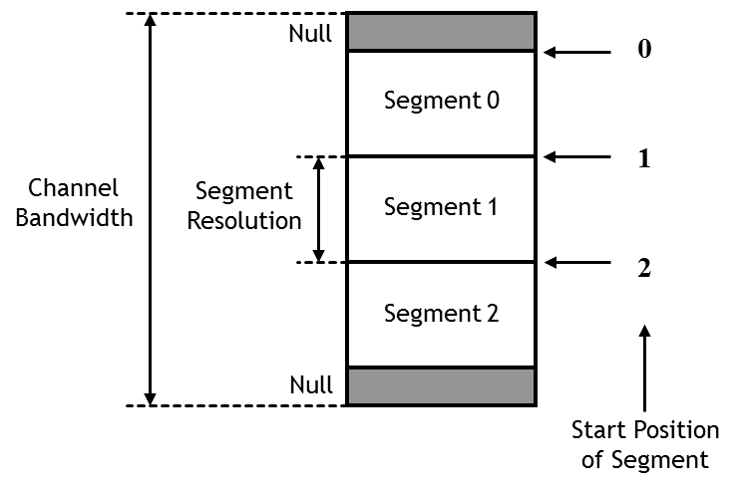

Figure 00-Segment structure

Table 00-Segment bandwidth
PHY mode  Segment index | PHY mode 1 |  | PHY mode 2
PHY mode  Segment index | DS  (subchannels) | US  (subchannels) | DS  (tiles) | US  (tiles)
Size of Segment 1 | 10 | 20 | 72 | 70
Size of Segment 2 | 10 | 20 | 68 | 70
Size of Segment 3 | 10 | 20 | 68 | 70

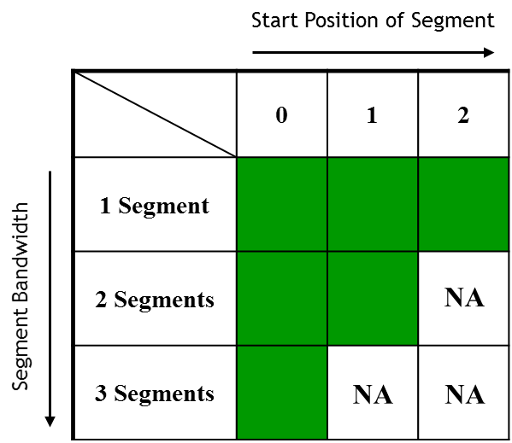

Figure 01-Combination of start position of segment and segment bandwidth

Change the section 7.7.2.1.2.2 as follows:

7.7.2.1.2.2 DS Multi-Zone Configuration IE
A CPE shall be able to decode the DS Multi-Zone Configuration IE shown in Table G1. An A-BS shall transmit

this IE for multi-hop relay operations.

Table G1—DS Multi-Zone Configuration IE format
Syntax | Size | Notes

DS Multi-Zone Configuration_IE() {

Multi-Zone Configuration{
Number of zones | 8 bits | Number of zones including access and relay zones.  Number of zones (0) is not available of DS. Number of zone (1) shall be access zone.

For(i=1; i =< Number of zones; i++){
Zone Index | 8 bits | Increase the index from 0 to Number of Zones-1
Zone Mode | 2 bits | 0: access zone  1: centralized relay zone  2: distributed relay zone
Start Position of Segment | 2 bits | 00: 0  01: 1  10: 2  11: If ‘Zone Mode’ is set to Access or Centralized Relay Zone
Segment Bandwidth | 2 bits | 00: one segment from start position  01: two segments from start position  10: three segments from start position  11: If ‘Zone Mode’ is set to Access or Centralized Relay Zone
PHY Mode | 1 bit | 0: PHY Mode 1  1: PHY Mode 2

}
if (Zone mode == 2) { |  | Distributed Relay Zone (DRZ) mode
SID | 13 bits | SID of distributed scheduling A-CPE

}

}

}

Insert the section 9.4.1.5 as follows:

9.4.1.5 Local frame preamble

The local frame preamble shall use the T_{CP}=1/4T_{FFT}. Three different preamble carrier sets are defined, differing in the allocation of subcarriers. Those subcarriers are modulated using a boosted BPSK modulation with a specific pseudo-noise (PN) code.

The preamble carrier-sets are defined using Equation (xx1).

PreambleCarrierSetn = n + 3k (xx1)
where
PreambleCarrierSetn specifies all subcarriers allocated to the specific preamble
n is the designating number of the preamble carrier-set indexed 0, 1, and 2
k is a running index. 0...559

Each start position of segment uses a preamble composed of a single carrier-set in the following manner:
— Start position of segment 0 uses preamble carrier-set 0 (n =0).
— Start position of segment 1 uses preamble carrier-set 1 (n =1).
— Start position of segment 2 uses preamble carrier-set 2 (n =2).

In the case of start position of segment 0, the DC carrier will not be modulated at all, and the appropriate PN will be discarded. Therefore, the DC carrier shall always be zeroed.

Each start position of segment eventually modulates each third subcarrier. As an example, Figure XX1 depicts the preamble of start position of segment 0. In this figure, subcarrier 0 corresponds to the first subcarrier used in the preamble symbol.

Figure XX1—Example of basic structure of preamble (for the case of n =0)

The PN series modulating the preamble carrier-set is defined in Table XX1. The series modulated depends on the start position of segment and segment bandwidth used. The defined series shall be mapped onto the preamble subcarriers in ascending order. Table XX1 includes the PN sequence in a hexadecimal format. The value of the PN is obtained by converting the series to a binary series (Wk) and mapping the PN starting from the MSB of each symbol to the LSB (0 mapped to +1 and 1 mapped to –1). For example, for Local Frame Preamble 0 (the first row of Table XX1), Wk = 001001010001..., and the mapping shall follow: –1 –1 +1 –1 –1 +1 –1 +1 –1 –1 –1 +1....

For the preamble symbol, there will be 184 guard band subcarriers on each side of the spectrum.

The symbols in the DS preamble shall be modulated according to Equation (xx2).

$\text{Re}\left\{\text{Pr}\text{eambleModulated}\right\}=2⋅\sqrt{3}⋅\left(\frac{1}{2}−W_{k}\right), \text{Im}\left\{\text{Pr}\text{eambleModulated}\right\}=0$ (xx2)

Table XX1—Local frame preamble modulation series for segmentation scheme

Preamble Type | Start Position of Segment | Segment Bandwidth | Series to modulate (Wk)
Local Frame Preamble 0 | 0 | 1 segment | 0x251D994101EDA04D8BD0B8EA6FA20AE590C2CC199AB083C6AE61F091F2DD41D989EC164B1481D611BE9CEA0094AFE9DB56A4763F55B26E54EAB73ACD7D4BBA64C1421BC3EB9D
Local Frame Preamble 1 | 0 | 2 segments | 0x572B008CAE935937061963E9567C204CB881C66F6C70DC9316A4006F9CDF449C19E5EC29CCFC42786A82330FC7279F99F1DFCC4246B1234F792B623341EBA8DBDAC7FD337206
Local Frame Preamble 2 | 0 | 3 segments | 0x9D7B838B01289DA478424A99E6B5C35E7D6D79FCC9ADEFEE741BFBD48261B9A427AE8994EB230CF27D770B7CDD53A01821C63ADD01236D481BFEF0085FF21DF2044E054E9113
Local Frame Preamble 3 | 1 | 1 segments | 0xBBF8D4EE09564B33B49FFA37179626165084481424D61EC7592A97D80A66FA6797B1A0C493987566D49A6B2786BC9706F8168264BD24F9A8BD86EEBC0211848DFB2B477E2CF3
Local Frame Preamble 4 | 1 | 2 segments | 0x3A13D1C743143CE5E66B0AC149147AA2E4624EF574EB4D49FC698483BFEB60FB07B286EDB255BC19C0AD0D53669AF9E41E7CF22795EAF0CDCB9F1EBAF6979B05A0373A3C7403
Local Frame Preamble 5 | 2 | 1 segments | 0x9D6E088D4BF521B816766CDD6DEC121DD3C2101F30B8479CADA2EDA38CC97B865D78BDDC1A50843DCC6547D9B4CE4EF1A3E9661C42648013DB35E2E69D7404D52DACA4886F5D

Insert the section 9.4.1.6 as follows:

9.4.1.6 Local CBP preamble

The local CBP preamble shall have a duration of 1 OFDM symbol. The preamble structure is used by the same nanner as described in 9.4.1.5. The PN series modulating the local CBP preamble carrier-set is defined in Table XX2. The series modulated depends on the start position of segment and segment bandwidth used. The defined series shall be mapped onto the local CBP preamble subcarriers in ascending order. Table XX2 includes the PN sequence in a hexadecimal format. The value of the PN is obtained by the same manner as described in 9.4.1.5.

Table XX2—Local CBP preamble modulation series

Preamble Type | Start Position of Segment | Segment Bandwidth | Series to modulate (Wk)
Local CBP Preamble 0 | 0 | 1 segment | 0xF3E5596544A8D30FF9DAA3AB6CBE5EC769CAB9F0E2F9FF3D1D27619481C8A1A3EC4286F8207F1C69816CC13E995C38C1E4D62AD594B2B02CDEE05A0F1BD18BCA09FC2B1DC72B
Local CBP Preamble 1 | 0 | 2 segments | 0xFCAEC6B1C7027793A48849AD347AE875408955E7F2AAC5FF9904A2D0D904C931795A1BDA94D9DCABA8BA77152A69B89F008680F34505343E591F3EB3CF103BF97DA73BC87FC9
Local CBP Preamble 2 | 0 | 3 segments | 0x1F6C5C088F9FF6E85171FF5434B95DEB270F1C926F738B8167566D24EC3F7A1BEDC7CC3B913EC2DB60B4103739C07C10DB5D036A9B48223CE4037E148205DD8177084A97E739
Local CBP Preamble 3 | 1 | 1 segment | 0x1A6988580366EDA426EDA5EC69AEC0B9D77D733AC09338B2E66BCBA5F1960FEE2C08477CB6F80DB152B4EF01E7FBFD5961A16C954EFEB629124F9789B34411713ED05A0EF02C
Local CBP Preamble 4 | 1 | 2 segments | 0xFA54537894CC41ADE3960B29C89DCAC398CEDFB2AB6BCB61D02B877208A71DD8760FFCABA593996852CAE9AE7E7FF7633EAF24CD2AAC1229E10D9847837CC20C46270E8F824F
Local CBP Preamble 5 | 2 | 1 segment | 0x8C88EE32C92B5741BBF6A7026E0C268520653A0A948EA318A316508A4602A75DED6AF1D33BCB0B83E8A3C7372E0779FC5C10AA16063AF909031455A18EA324FBD5FECF499D83

Change the section 9a.4.1.1 as follows:

9a.4.1.1 Frame preamble

The first symbol of the DS transmission is the preamble. Three different preamble carrier sets are defined, differing in the allocation of subcarriers. Those subcarriers are modulated using a boosted BPSK modulation with a specific pseudo-noise (PN) code.

The preamble carrier-sets are defined using Equation (3).

PreambleCarrierSetn = n + 3k (3)
where

PreambleCarrierSetn specifies all subcarriers allocated to the specific preamble
n is the designating number of the preamble carrier-set indexed 0, 1, and 2
k is a running index. 0...283

Each start position of segment uses a preamble composed of a single carrier-set in the following manner:
— Start position of segment 0 uses preamble carrier-set 0 (n =0).
— Start position of segment 1 uses preamble carrier-set 1 (n =1).
— Start position of segment 2 uses preamble carrier-set 2 (n =2).

In the case of start position of segment 0, the DC carrier will not be modulated at all, and the appropriate PN will be discarded. Therefore, the DC carrier shall always be zeroed.

Each start position of segment eventually modulates each third subcarrier. As an example, Figure EL1 depicts the preamble of start position of segment 0. In this figure, subcarrier 0 corresponds to the first subcarrier used in the preamble symbol.

Figure EL1—Example of basic structure of preamble (for the case of n =0)

The PN series modulating the preamble carrier-set is defined in Table HW1. The series modulated depends on the start position of segment and segment bandwidth used. The defined series shall be mapped onto the preamble subcarriers in ascending order. Table HW1 includes the PN sequence in a hexadecimal format. The value of the PN is obtained by converting the series to a binary series (Wk) and mapping the PN starting from the MSB of each symbol to the LSB (0 mapped to +1 and 1 mapped to –1). For example, for Frame Preamble (the first row of Table HW1), Wk = 101001101111..., and the mapping shall follow: +1 –1 +1 –1 –1 +1 +1 –1 +1 +1 +1 +1....

For the preamble symbol, there will be 86 guard band subcarriers on each side of the spectrum.

The symbols in the DS preamble shall be modulated according to Equation (4).

$\text{Re}\left\{\text{Pr}\text{eambleModulated}\right\}=2⋅\sqrt{3}⋅\left(\frac{1}{2}−W_{k}\right), \text{Im}\left\{\text{Pr}\text{eambleModulated}\right\}=0$ (4)

Table HW1—Frame preamble and local frame preamble modulation series

Preamble Type | Start Position of Segment | Segment Bandwidth | Series to modulate (Wk)
Frame Preamble | - | - | 0xA6F294537B285E1844677D133E4D53CCB1F182DE00489E53E6B6E77065C7EE7D0ADBEAF
Local Frame Preamble 0 | 0 | 1 segment | 0x668321CBBE7F462E6C2A07E8BBDA2C7F7946D5F69E35AC8ACF7D64AB4A33C467001F3B2
Local Frame Preamble 1 | 0 | 2 segments | 0x1C75D30B2DF72CEC9117A0BD8EAF8E0502461FC07456AC906ADE03E9B5AB5E1D3F98C6E
Local Frame Preamble 2 | 0 | 3 segments | 0x5F9A2E5CA7CC69A5227104FB1CC2262809F3B10D0542B9BDFDA4A73A7046096DF0E8D3D
Local Frame Preamble 3 | 1 | 1 segments | 0x82F8A0AB918138D84BB86224F6C342D81BC8BFE791CA9EB54096159D672E91C6E13032F
Local Frame Preamble 4 | 1 | 2 segments | 0xEE27E59B84CCF15BB1565EF90D478CD2C49EE8A70DE368EED7C9420B0C6FFAF9AF035FC
Local Frame Preamble 5 | 2 | 1 segments | 0xC1DF5AE28D1CA6A8917BCDAF4E73BD93F931C44F93C3F12F0132FB643EFD5885C8B2BC

Change the section 9a.4.1.2 as follows:

9a.4.1.2 CBP preamble
The CBP and local CBP preamble shall have a duration of 1 OFDM symbol. The preamble structure is used by the same nanner as described in 9a.4.1.1. The preamble carrier-set 0 is used for CBP preamble. The PN series modulating the CBP and local CBP preamble carrier-set is defined in Table HX1. The series modulated depends on the start position of segment and segment bandwidth used. The defined series shall be mapped onto the CBP and local CBP preamble subcarriers in ascending order. Table HX1 includes the PN sequence in a hexadecimal format. The value of the PN is obtained by the same manner as described in 9a.4.1.1.

Table HX1—CBP preamble and local CBP preamble modulation series

Preamble Type | Start Position of Segment | Segment Bandwidth | Series to modulate (Wk)
CBP Preamble | - | - | 0x61AF26BD39A9FFF52826625E04ADA299385A373FA946D837D754E6CFEBB26F5C03B87CF
Local CBP Preamble 0 | 0 | 1 segment | 0xD77D97CDB93DBEAA65CAFA146F40D72B5E80944F750E07325DC164ED60F32434BC7187D
Local CBP Preamble 1 | 0 | 2 segments | 0x4529D9CA65AF49C1C39BDC18CFAB87E03FE4DAFC0A48FF1457D46B0DF66B414A23ACDDB
Local CBP Preamble 2 | 0 | 3 segments | 0x33AC0261DAA57C1D611EBA1C730D50AFEE5BE3E849030A4E891BC8C5F4C78DCDDFEA263
Local CBP Preamble 3 | 1 | 1 segments | 0xBED48C704F02A84F03BCD299D919DA56F7B71EDF8A0F8A25E8F8496F95A44CE2B9F74C9
Local CBP Preamble 4 | 1 | 2 segments | 0x0ECCBE0902EBF4B4C29506014A3706622784B7B2D5153E10AD3112DC5E45277A32E79DE
Local CBP Preamble 5 | 2 | 1 segments | 0x7CB4937889C7DFD9AA2D37235E06F993D3D4F5D515B39CA652F62397C08457D66BC5A36

